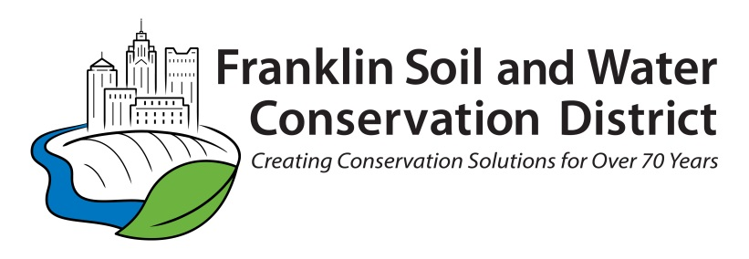

FOR IMMEDIATE RELEASE

Contact: David Reutter, dreutter@franklinswcd.org , (614) 486-9613 (office)

Stormwater Awareness Week Urges Ohioans to Be the Change for Clean Water This October

4/5/2022 Franklin County, Ohio - Communities across Ohio are urging residents to “Be the Change for Clean Water” and take action during Stormwater Awareness Week, October 16-22, 2022.
"Stormwater Awareness Week offers central Ohioans an opportunity to learn how they can take small actions to make a big impact on protecting drinking water,” said Jennifer Fish, director of the Franklin Soil and Water Conservation District. While rainwater is great for lawns and gardens, it can be dangerous for streams and rivers.
Stormwater can push common household items – such as trash, lawn fertilizer, or paint- into local waterways, threatening our environment and clean drinking water. During Stormwater Awareness Week, Soil and Water Conservation District’s throughout Ohio are urging residents to take one or more of the following actions:
- Pick up trash in your neighborhood or a local park. It can be a family game to see who can fill up a bag first.
- Check the weather report before applying fertilizer to your lawn or any oil or chemicals to driveways and sidewalks. This will protect the environment and your pocketbook.
- Make sure lawns have 3-4 inches of topsoil under the grass. This will reduce runoff, as well as make lawns easier to maintain.
- Plant native plants that have deep roots, which will help break up clay soil and increase the amount of water remaining on a property while benefiting birds, butterflies and bees.
- Plant a tree in your yard or install a rain garden. Trees can soak up 900 gallons of rain a year and a well-designed rain garden almost entirely reduce stormwater from a property.
- Encourage local businesses to become a Water Quality Partner!

Pollution left on roadways, sidewalks, driveways, and parking lots drains directly to our streams and rivers. Simple actions can improve water quality and reduce stormwater runoff. Stormwater can also erode away streams, which can cause flooding. Each year, Conservation Districts investigate multiple sources of pollution and assists hundreds of homeowners concerned with stream erosion and flooding, all caused by stormwater runoff.
There is so much we can do for Clean Water in Ohio. Please take a moment at home and at work during the week of October 16th-22nd, to make your family and co-workers aware of what they can do to make Ohio a great place to live, work and play.
For more information on programs and resources for stormwater education and conservation visit franklinswcd.org and bethechangeforcleanwater.org.

Franklin Soil and Water Conservation District 1404 Goodale Blvd., Suite 100, Columbus, Ohio 43212 (614) 486-9613 franklinswcd.org

The mission of Franklin Soil and Water Conservation District is to promote land-use decisions for the conservation, protection and improvement of soil and water resources by providing information assistance through effective partnering, technical guidance and education.

